**Demonstrate installation and configuration of AutoIT.**

**Installation**

**Got to the autoit website :** [AutoIt Downloads - AutoIt (autoitscript.com)](https://www.autoitscript.com/site/autoit/downloads/)

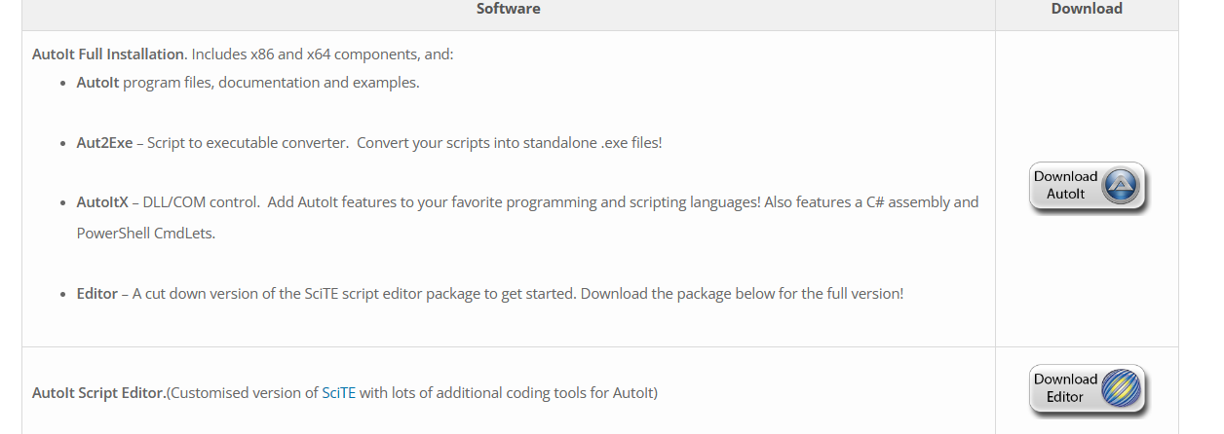

**Download both autoit and editor**

**Install both executables.**

**Finally you should be able to open editor and autoitinfo**

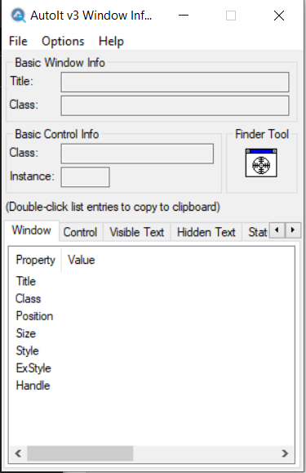

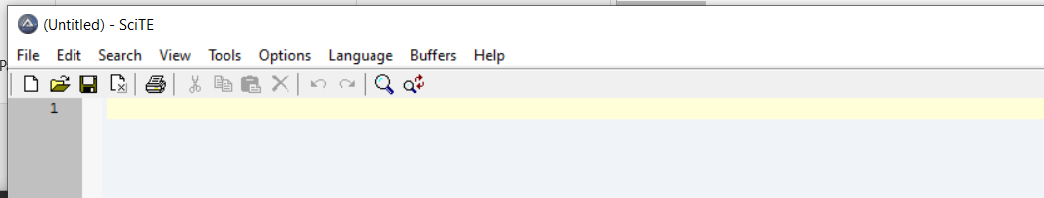

We can write scripts in editor and we can use autoitinfo to see the title and class of the window.